HTML & CSS – Class 6

Multimedia & Validating
Slide 2
Harvestfresh >brusselsprouts.htm

Slide 3
Harvestfresh >brusselsprouts.htm
In the head section add the following <meta>.
<meta name="viewport" content="width=device-width, initial-scale=1.0">

View the example at http://tauruswright.tripod.com .

Slide 4
Example grid-vew column classes:
.col-1 {width: 8.33%;}
.col-2 {width: 16.66%;}
.col-3 {width: 25%;}
.col-4 {width: 33.33%;}
.col-5 {width: 41.66%;}
.col-6 {width: 50%;}
.col-7 {width: 58.33%;}
.col-8 {width: 66.66%;}
.col-9 {width: 75%;}
.col-10 {width: 83.33%;}
.col-11 {width: 91.66%;}
.col-12 {width: 100%;}

Harvestfresh >brusselsprouts.htm
Create an embedded style sheet and add the following code:
.column1 {width: 25%;}
.column2 {width: 50%;}
.column3 {width: 75%;}
.column4 {width: 100%;}
Apply ‘column4’ to the recipe name <h2> and to the directions and footer using a <div> to group them.
Apply ‘column2’ to the image’s <p> and to the ingredients heading and list using a <div> to group them.
Save and Preview your page.
Add the following code to the embedded stylesheet: it will apply those properties to all of the column classes. The box-sizing: border-box will make the adjust an element’s width so that it will include the size of padding and borders.
[class*="column"] { float: left; padding: 1%; border: 1px solid #b7dce8; }

* {box-sizing: border-box;}
Save and Preview your page.

Add the following code to the embedded stylesheet to tell the browser not to float “rows” of information.
.row {clear: left;}
Add the row to the <div> for the directions and footer. Even though it is not floating around the information above it, this will keep it that way should you change the widths of the image or ingredients columns.
Slide 5
Harvestfresh >brusselsprouts.htm
Add the following code to the embedded style sheet:
img {max-width: 100%; height: auto; }
Save and Preview the page. Resize it to see the image adjust to the browser size.

Slide 6
Create a new .css document named ‘brusselsmedia.css’ and enter the following code:
@media only screen and (max-width: 600px) {class*="column"] {clear:float; width:100%; text-align:center;} ul li {list-style-image:none; list-style-type:none;}}
Use the <link> to link ‘brusselsmedia.css’ to the page.
Cut the rules out of the embedded style sheet and add them to the ‘brusselsmedia.css’ page.
Save brusselsmedia.css and brusselsprouts.htm. Preview in your browser, resize the page to see the change.

Slide 1
fast_track> links.htm
Click after the </p> on line 34 and type the following code:
<form action="http://www.mydata.com/data.asp" method="post" enctype="text/plain">

</form>

Slide 1
________________________________________________________________________________________________________________________________________________________________________________________________________________________________________________________________________________________________________________________________________________________________________________________________________
________________________________________________________________________________________________________________________________________________________________________________________________________________________________________________________________________________________________________________________________________________________________________________________________________
_____________________________________________________________________________

Slide 3
Click above the </form> and type the following code:
Name <input type="text" size="50" /><br />
Email <input type="text" size="50" /><br />
Save and Preview in Browser
Continuing, type the following code:
For which products and services would you like more information?<br />
<input type="checkbox" name="products" value="cycling" /> Cycling
<input type="checkbox" name="products" value="inline" /> Inline Skates
<input type="checkbox" name="products" value="skateboards" /> Skateboards<br />
Save and Preview in Browser

Continuing, type the following code:
Would you like to receive our free monthly newsletter?<br />
<input type="radio" name="newsletter" value="yes" checked="checked" /> Yes
<input type="radio" name="newsletter" value="no" />
No<br />
Save and Preview in Browser

________________________________________________________________________________________________________________________________________________________________________________________________________________________________________________________________________________________________________________________________________________________________________________________________________
________________________________________________________________________________________________________________________________________________________________________________________________________________________________________________________________________________________________________________________________________________________________________________________________________
________________________________________________________________________________________________________________________________________________________________________________________________________________________________________________________________________________________________________________________________________________________________________________________________________
________________________________________________________________________________________________________________________________________________________________________________________________________________________________________________________________________________________________________________________________________________________________________________________________________

Slide 4
Continuing, type the following code:
Comments/Questions/Suggestion:<br />
<textarea cols="50" rows="5" name="comments"></textarea><br />
Save and Preview in Browser
________________________________________________________________________________________________________________________________________________________________________________________________________________________________________________________________________________________________________________________________________________________________________________________________________
________________________________________________________________________________________________________________________________________________________________________________________________________________________________________________________________________________________________________________________________________________________________________________________________________
Slide 5
Continuing, type the following code:
What is your favorite terrain?
<select name="experience">
<option value="pvmt">Pavement</option>
<option value="grvl">Gravel</option>
<option value="sand">Sand</option>
<option value="grss">Grass</option>
</select><br />
Save and Preview in Browser
____________________________________________________________________________________________________________________________________________________________________________________________________________________________________________________________________________________________________________________
Slide 6
______________________________________________________________________________________________________________________________________________________________________________________________________________________________________________________________________________________________________
________________________________________________________________________________________________________________________________________________________________________________________________________________________________________________________________________________________________________________________________________________________________________________________________________
________________________________________________________________________________________________________________________________________________________________________________________________________________________________________________________________________________________________________________________________________________________________________________________________________

Slide 7
Add only the bold code as indicated below:
<label>Name <input type="text" id="name" size="50" /></label>
<br />
<label for="email">Email</label> <input type="text" id="email" size="50" /><br />
Save and Preview in Browser
______________________________________________________________________________________________________________________________________________________________________________________________________________________________________________________________________________________________________
____________________________________________________________________________________________________________________________________________________________________________________________________
Slide 8
Above the </form>, type the following code:
<button type=“submit”>Send Info</button>
<button type=“reset”>Clear Form</button>
OR
<input type="submit" value="Send Info" />
<input type="reset" value="Clear Form" />
Save and Preview in Browser
Close fast_track/links.htm
________________________________________________________________________________________________________________________________________________________________________________________________________________________________________________________________________________________________________________________________________________________________________________________________________
Slide 11
Fasttrack → multimedia-links.htm
Below the Adding Multimedia comment type:
<p>
<a href="Background.wav" target="_blank"> Click here to listen to a sample of music on our cycling cd </a>
</p>
<audio controls="controls" height="50px" width="100px">
<source src="Background.wav" type="audio/wav" />
<embed height="50px" width="100px" src="Background.wav" />
</audio>
________________________________________________________________________________________________________________________________________________________________________________________________________________________________________________________________________________________________________________________________________________________________________________________________________
Slide 12
Fasttrack → multimedia-links.htm
Type the following code below the Embed Tag comment
<h3> Embed Tag Example</h3>
<embed width="400" height="75" src="music.mp3" />
________________________________________________________________________________________________________________________________________________________________________________________________________________________________________________________________________________________________________________________________________________________________________________________________________
________________________________________________________________________________________________________________________________________________________________________________________________________________________________________________________________________________________________________________________________________________________________________________________________________
Slide 13
Fasttrack → multimedia-links.htm
Type the following code below the Object Tag comment:
<h3> Object Tag Example</h3>
<object width="400" height="75" data="music.mp3">How odd! Your browser does not support the OBJECT tag.</object>
________________________________________________________________________________________________________________________________________________________________________________________________________________________________________________________________________________________________________________________________________________________________________________________________________
____________________________________________________________________________________________________________________________________________________________________________________________________
Slide 14
Fasttrack → multimedia-links.htm
Type the following code below the Legacy Video Code comment. (A text file is provided from which you can copy/paste the code. It is called “legacy-multimedia-code.txt”)
<h3> Legacy Video Example</h3>
<object classid="clsid:02BF25D5-8C17-4B23-BC80-D3488ABDDC6B" width="250 "height="250"
codebase="http://www.apple.com/qtactivex/qtplugin.cab">
<param name="SRC" VALUE="cyclers.mov">
<param name="AUTOPLAY" VALUE="true">
<param name="CONTROLLER" VALUE="true">
<embed src="cyclers.mov" width="250" height="250" autoplay="true" controller="true" pluginspace="http://www.apple.com/quicktime/download/">
</embedD>
</object>
Slide 15
Fasttrack → multimedia-links.htm
Type the following code below the HTML Audio comment:
<h3> HTML 5 Audio Tag Example</h3>
<audio controls=”controls”>
<source src="music.mp3" type="audio/mpeg">
<source src="music.ogg" type="audio/ogg">
Your browser does not support this audio format.
</audio>
________________________________________________________________________________________________________________________________________________________________________________________________________________________________________________________________________________________________________________________________________________________________________________________________________
Slide 16
________________________________________________________________________________________________________________________________________________________________________________________________________________________________________________________________________________________________________________________________________________________________________________________________________
________________________________________________________________________________________________________________________________________________________________________________________________________________________________________________________________________________________________________________________________________________________________________________________________________
Slide 17
________________________________________________________________________________________________________________________________________________________________________________________________________________________________________________________________________________________________________________________________________________________________________________________________________
________________________________________________________________________________________________________________________________________________________________________________________________________________________________________________________________________________________________________________________________________________________________________________________________________
Slide 18
________________________________________________________________________________________________________________________________________________________________________________________________________________________________________________________________________________________________________________________________________________________________________________________________________
________________________________________________________________________________________________________________________________________________________________________________________________________________________________________________________________________________________________________________________________________________________________________________________________________
______________________________________________________________________________________________________________________________________________________________________________________________________________________________________________________________________________________________________
Slide 19
Goto http://www.youtube.com/
Search for: angry alien bunnies [ENTER]
Select a video
Click the share button
Click the embed link and copy the code
Go to multimedia-links.htm and paste the code below the Legacy Video </object>.
<iframe width="420" height="315" src=”http://www.youtube.com/embed/BKvCEvJu8vA” frameborder="0" allowfullscreen></iframe>
The Youtube code is missing the “http:” add it where indicated above.
Save and Preview in Browser
Slide 20
________________________________________________________________________________________________________________________________________________________________________________________________________________________________________________________________________________________________________________________________________________________________________________________________________
__________________________________________________________________________________________________
________________________________________________________________________________________________________________________________________________________________________________________________________________________________________________________________________________________________________________________________________________________________________________________________________
Slide 21
Go to http://www.w3schools.com/tags/tag_doctype.asp (HTML Reference> DOCTYPE)
Find and select the HTML 5 <!DOCTYPE html>,copy it.
Go to multimedia-links.htm and paste the HTML 5 DOCTYPE in the place of the current one. Remember to remove the xml namespace from the <html>
Save and Preview in Browser
______________________________________________________________________________________________________________________________________________________________________________________________________________________________________________________________________________________________________
______________________________________________________________________________________________________________________________________________________________________________________________________________________________________________________________________________________________________
____________________________________________________________________________________________________________________________________________________________________________________________________
Slide 22
Validating → fasttrack →index.htm
http://validator.w3.org/
Choose Validate by File Upload
Click “Choose file”
Choose the index.htm page in the fast_track folder.Click “More Options”
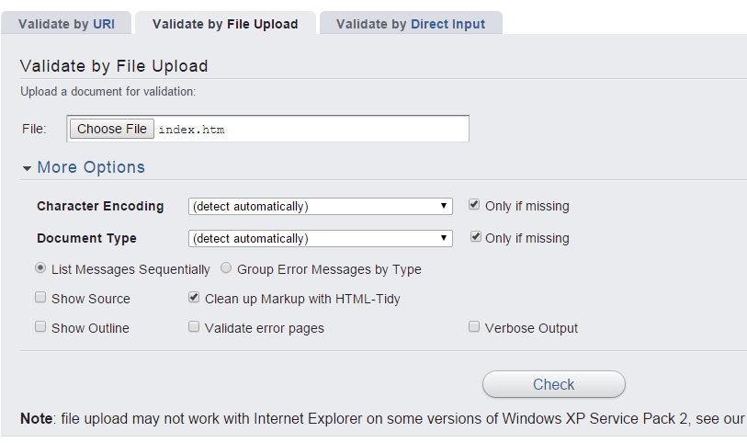
Click Check
Note the list of errors and the corrected code below. You could copy this code and paste it into the index.htm document.
________________________________________________________________________________________________________________________________________________________________________________________________________________________________________________________________________________________________________________________________________________________________________________________________________
_________________________________________________________________________________________________________________________________________________________________________________________________________________________________________________________________________________________________________________________________________________________________________________________________

